Pre-Production for Final Project:

**Pitch Board:**

Website Name: Jack Mal’s Portfolio

Elevator Pitch: I want to make a website that showcases my work experience, skills and my career ambitions. A personalized version of Linkedin.

Long Pitch: I want to create a professional profile that highlights my career achievements so far. I want it to showcase my current and previous jobs I’ve held, skills I have gained from my experience (both technological and behavioral). I want this page of the website to act as my resume. I want the other page to showcase a picture of me along with two short paragraphs about my career ambitions and my goals in life.

Personas:

1. Recruitment professionals. Typically, 20-50 years old. Have a background in HR and know about the computer science, UX, and web development industry.
2. Colleagues and business contacts. Typically 20-60 years old. Good knowledge of Linkedin and professions related to computer science, web development, and UX research.

Shorthand Flow:

Wireframe:

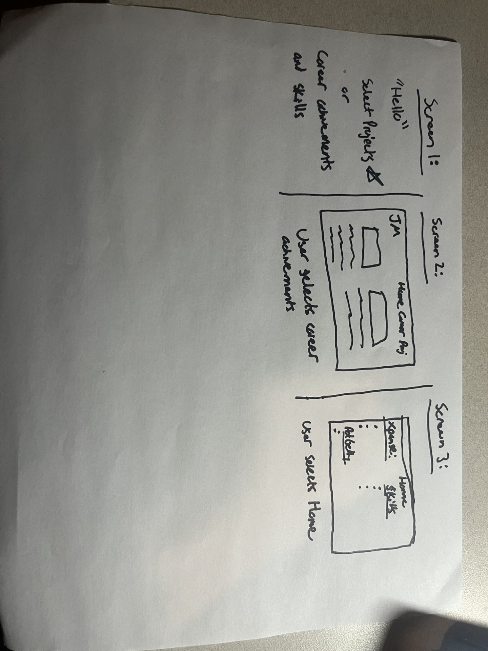

Comp:



